**WEB DESIGNING ASSIGNMENT MODULE(HTML)-1**

**Q.Are the HTML tags and ELEMENTS the same thing?**

**ANS.1:**

HTML elements are made up of a start tag, content tag, and end tag. An element is a combination of an opening tag, a closing tag, and content. For example, <p>This is the content</p> is an HTML element.

**Q.What are tags and attributes in HTML?**

**ANS.2:**

In HTML, tags are the primary component that defines how content is structured and formatted, while attributes are used to define the characteristics of an element. Tags are written in angle brackets, such as <p> for a paragraph or <img> for an image.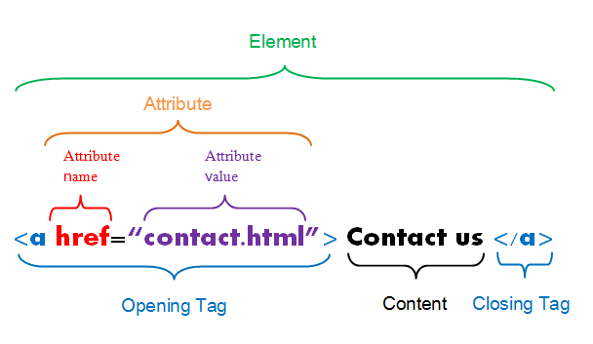

**Q. What are void elements in HTML?**

**ANS.3:**

In HTML, void elements are elements that cannot have any content between their start and end tags, but can have attributes.

**Q. What are HTML Entities ?**

**ANS.4:**

HTML entities are reserved characters that have special meaning when used in an HTML document.HTML entities are special characters that have a specific meaning when used in an HTML document. They are not present on a standard keyboard. Each code starts with an ampersand and ends with a semicolon.

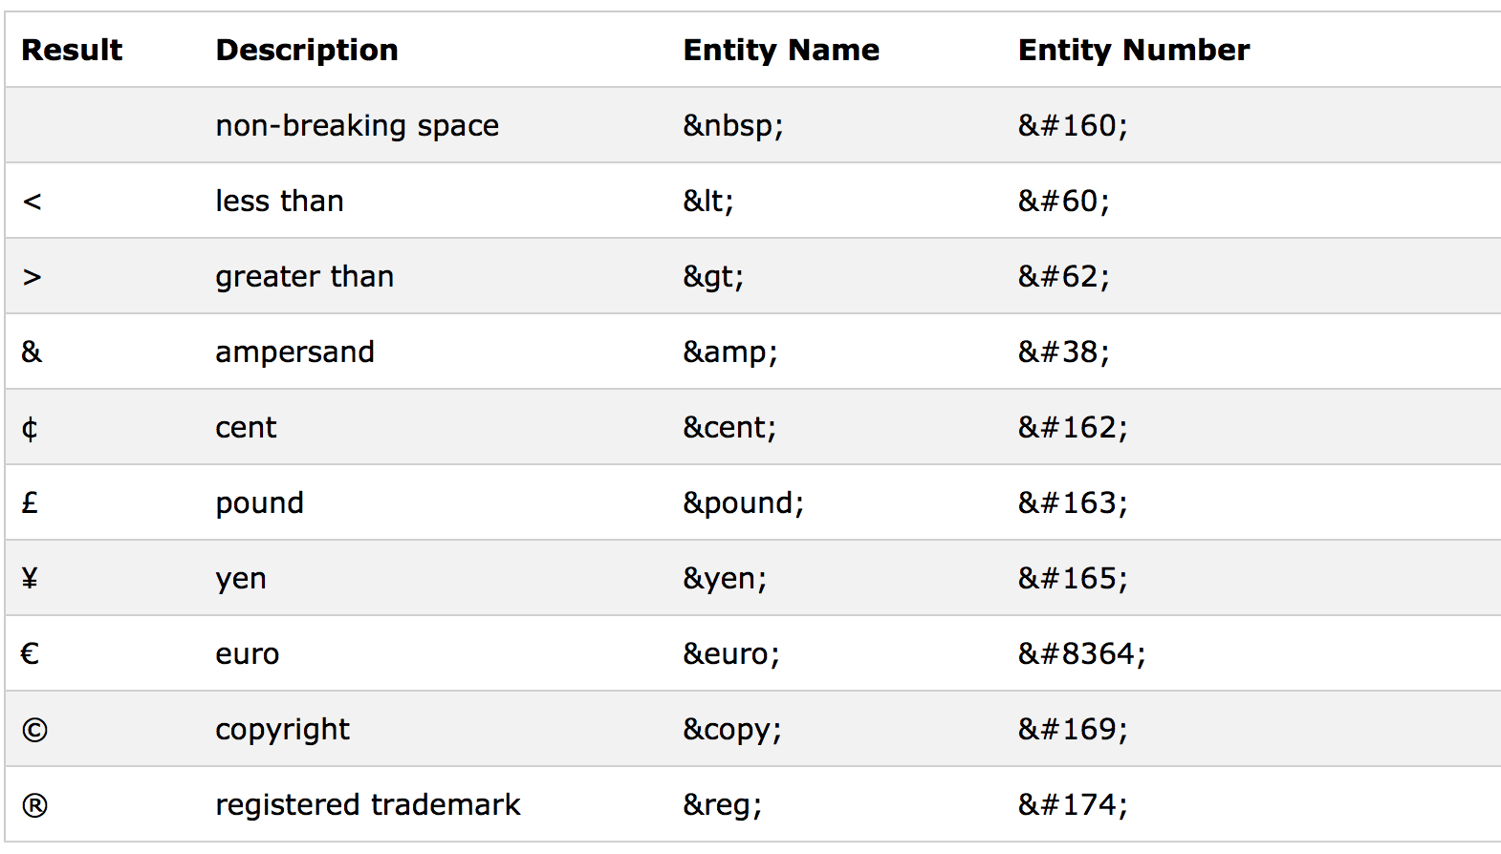

**Q. What are different types of lists in HTML ?**

**ANS.5:**

Unordered list: A list of items that have no specific order, with each item having a bullet point before it

Ordered list: A list of items that are numbered, with items typically starting with 1,A,a.

Description list: A list of words, each with a description.

<ol>

        <br><li>Strat</font></li>

       <br><li>Picture 1</li>

        <br><li>Picture 2</li>

        <br><li>Picture 3</li>

        <br><li>Picture 4</li>

        <br><li>Picture 5</li>

    </ol>

2. Unordered list <ul>

 <ul>

        <br><li>Strat</font></li>

       <br><li>Picture 1</li>

        <br><li>Picture 2</li>

        <br><li>Picture 3</li>

        <br><li>Picture 4</li>

        <br><li>Picture 5</li>

    </ul>

3. Definition list <dl>

    <dl>

        <br><dt>Strat</font></dt>

       <br><dd>Picture 1</dd>

        <br><dt>Picture 2</dt>

        <br><dd>Picture 3</dd>

        <br><dt>Picture 4</dt>

        <br><dd>Picture 5</dd>

    </dl>

**Q. What is the ‘class ’ attribute in HTML ?**

**ANS.6:**

The class attribute specifies one or more class names for an element. The class attribute is mostly used to point to a class in a style sheet.

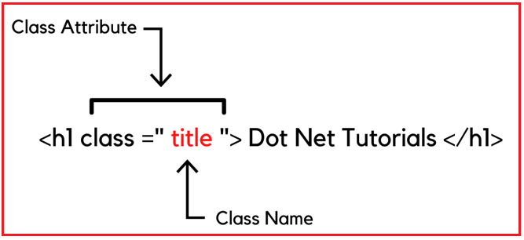

**Q. What is the difference between the ‘id’ attribute and the ‘class’ attribute of HTML elements ?**

**ANS.7:**

In HTML, the id and class attributes are both used to apply styling or functionality to elements. However, they have different purposes:

id attribute

Uniquely identifies an element on a page. Each id attribute within a page must be unique. For example, you can use an id on the div element that marks up the main content on a page.

class attribute

Identifies multiple elements as belonging to a particular group or having a shared style. Multiple elements on a page can have the same class value. For example, you can use a class to set up alternating row colors on a table.

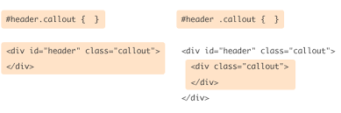

**Q. What are the various formatting tags in HTML ?**

**ANS.8:**

HTML Text Formatting

Bold text: <b> or <strong>

Italicized text: <i> or <em>

Underlined text: <u>

Superscript and subscript text: <sup> or <sub>

**Q. How is Cell Pedding different from Cell Spacing ?**

**ANS.9:**Cell padding and cell spacing are both created using the HTML <table> tag. The attribute type for cell padding is cellpadding, and the attribute type for cell spacing is cellspacing.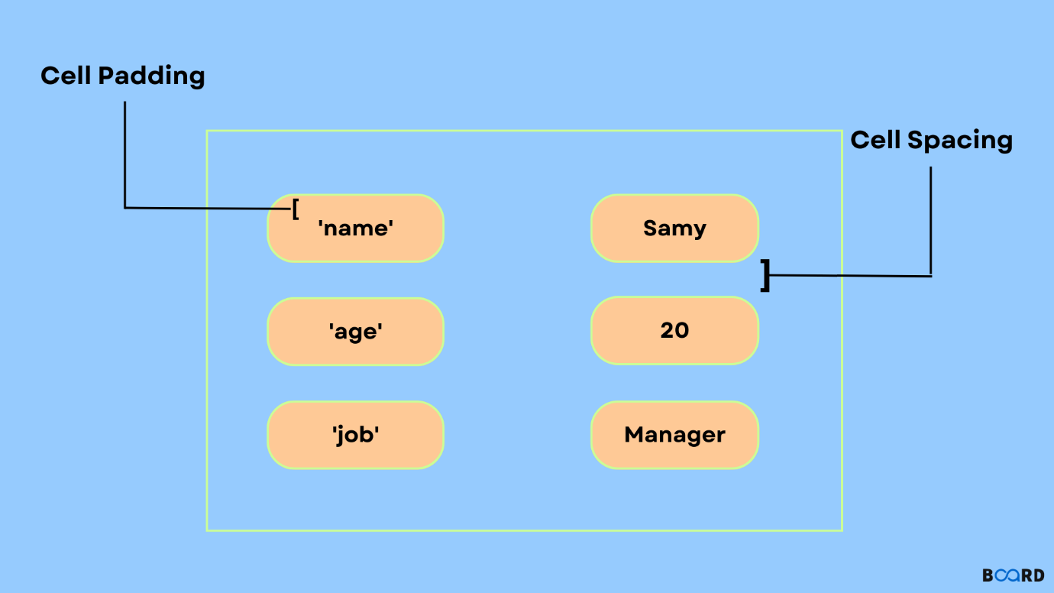

**Q. How can we club two or more rows or columns into a single row or column in an HTML table ?**

**ANS.10:**

To merge two or more rows or columns into a single row or column in an HTML table, you can use the colspan and rowspan attributes:

colspan: Specifies the number of columns to merge into a single cell. For example, colspan="2" combines the first two cells in the first column.

rowspan: Specifies the number of rows to merge.

</head>

<body>

    <table border="1">

        <tr>

          <td rowspan="2">Row 1, Col 1</td>

          <td>Row 1, Col 2</td>

          <td>Row 1, Col 3</td>

        </tr>

        <tr>

          <td>Row 2, Col 2</td>

          <td>Row 2, Col 3</td>

        </tr>

      </table>

</body>

**Q. What is the difference between a block-level element and an inline element ?**

**ANS.11:**

In HTML, block-level elements start on a new line and take up the entire width of the page. Inline elements do not start on a new line and only take up as much width as needed.

Here are the block-level elements in HTML:

[<address>](https://www.w3schools.com/tags/tag_address.asp),[<article>](https://www.w3schools.com/tags/tag_article.asp),[<aside>](https://www.w3schools.com/tags/tag_aside.asp),[<blockquote>](https://www.w3schools.com/tags/tag_blockquote.asp),[<canvas>](https://www.w3schools.com/tags/tag_canvas.asp),[<dd>](https://www.w3schools.com/tags/tag_dd.asp),[<div>](https://www.w3schools.com/tags/tag_div.asp),[<dl>](https://www.w3schools.com/tags/tag_dl.asp),[<dt>](https://www.w3schools.com/tags/tag_dt.asp),[<fieldset>](https://www.w3schools.com/tags/tag_fieldset.asp),[<figcaption>](https://www.w3schools.com/tags/tag_figcaption.asp),[<figure>](https://www.w3schools.com/tags/tag_figure.asp),[<footer>](https://www.w3schools.com/tags/tag_footer.asp),[<form>](https://www.w3schools.com/tags/tag_form.asp),[<h1>-<h6>](https://www.w3schools.com/tags/tag_hn.asp),[<header>](https://www.w3schools.com/tags/tag_header.asp),[<hr>](https://www.w3schools.com/tags/tag_hr.asp),[<li>](https://www.w3schools.com/tags/tag_li.asp),[<main>](https://www.w3schools.com/tags/tag_main.asp),[<nav>](https://www.w3schools.com/tags/tag_nav.asp),[<noscript>](https://www.w3schools.com/tags/tag_noscript.asp),[<ol>](https://www.w3schools.com/tags/tag_ol.asp),[<p>](https://www.w3schools.com/tags/tag_p.asp),[<pre>](https://www.w3schools.com/tags/tag_pre.asp),[<section>](https://www.w3schools.com/tags/tag_section.asp),[<table>](https://www.w3schools.com/tags/tag_table.asp),[<tfoot>](https://www.w3schools.com/tags/tag_tfoot.asp),[<ul>](https://www.w3schools.com/tags/tag_ul.asp),[<video>](https://www.w3schools.com/tags/tag_video.asp)

Here are the inline elements in HTML:

[<a>](https://www.w3schools.com/tags/tag_a.asp),[<abbr>](https://www.w3schools.com/tags/tag_abbr.asp),[<acronym>](https://www.w3schools.com/tags/tag_acronym.asp),[<b>](https://www.w3schools.com/tags/tag_b.asp),[<big>](https://www.w3schools.com/tags/tag_big.asp),[<br>](https://www.w3schools.com/tags/tag_br.asp),[<button>](https://www.w3schools.com/tags/tag_button.asp),[<code>](https://www.w3schools.com/tags/tag_code.asp),[<em>](https://www.w3schools.com/tags/tag_em.asp),[<i>](https://www.w3schools.com/tags/tag_i.asp),[<img>](https://www.w3schools.com/tags/tag_img.asp),[<input>](https://www.w3schools.com/tags/tag_input.asp),[<script>](https://www.w3schools.com/tags/tag_script.asp),[<select>](https://www.w3schools.com/tags/tag_select.asp),[<small>](https://www.w3schools.com/tags/tag_small.asp),[<span>](https://www.w3schools.com/tags/tag_span.asp),[<strong>](https://www.w3schools.com/tags/tag_strong.asp),[<sub>](https://www.w3schools.com/tags/tag_sub.asp),[<sup>](https://www.w3schools.com/tags/tag_sup.asp),[<textarea>](https://www.w3schools.com/tags/tag_textarea.asp),[<time>](https://www.w3schools.com/tags/tag_time.asp),[<tt>](https://www.w3schools.com/tags/tag_tt.asp),[<var>](https://www.w3schools.com/tags/tag_var.asp)

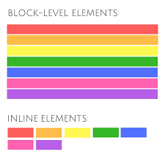

**Q. How to create a Hyperlink in HTML ?**

**ANS.12:**

Creating a hyperlink in HTML is quite simple. You use the <a> tag, which stands for "anchor," and specify the URL you want to link to in the href attribute.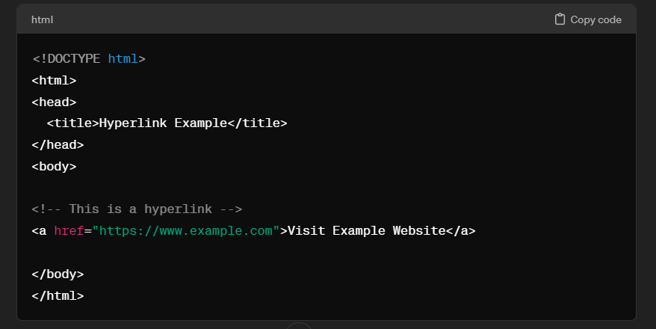

**Q. What is the use of an iframe tag ?**

**ANS.13:**

An iframe (inline frame) tag is an HTML element that contains another HTML document within it. It is often used to embed content from one web page, such as a video, form, document, or even a full web page, within a different web page. For example, you can use an iframe to embed content from another site within your page.

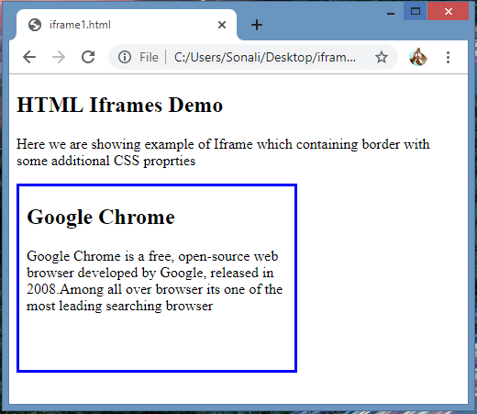

**Q. What is the use of a span tag ? Explain with example ?**

**ANS.14:**

In HTML, the span tag is used to group inline elements together and apply styles to them. The span tag is similar to the div tag, but they serve different purposes. A div element takes up the full width of its container, while span only takes up the width of its inner content.

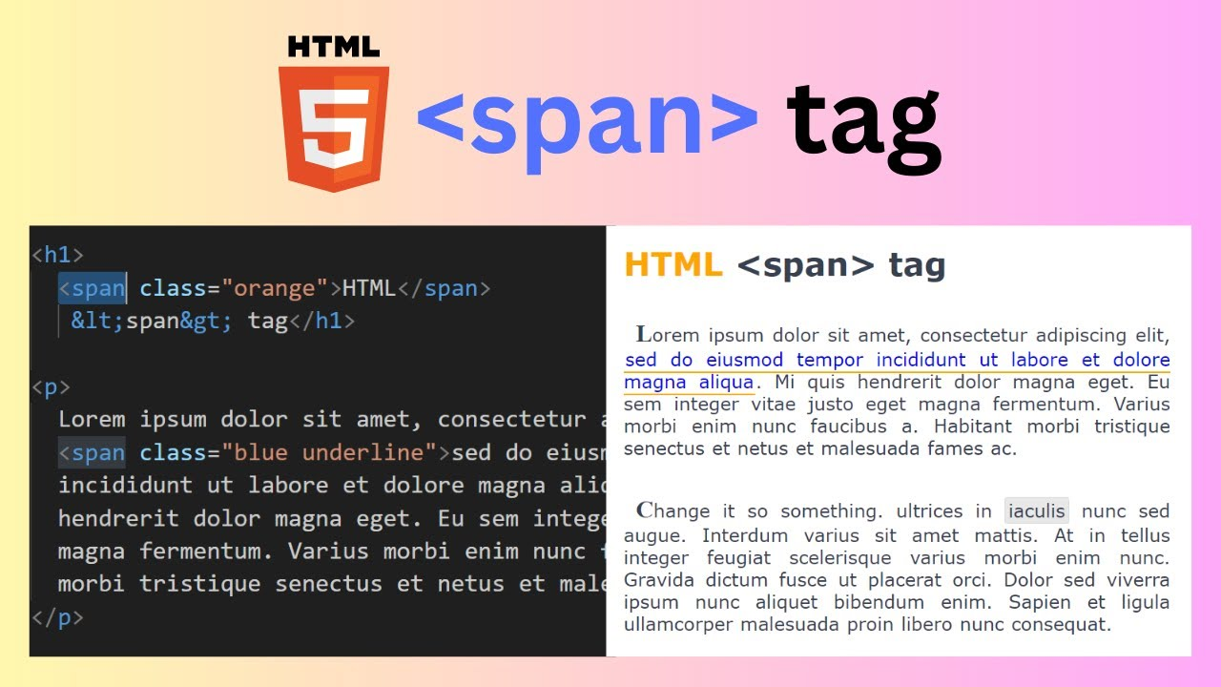

**Q. How to insert a picture into a background image of a web page ?**

**ANS.15:**

Insert a picture into background image of a web page, we can use css.

Background -image ,and then a picture is inserted as a background image in an HTML element with the

Class .picture we can adjust the background size ,width and height properties as needed

body {

        background-image: url('background-image.jpg');

        background-size: cover; /* Adjust as needed */

    }

    /* Optionally, you can style the image further */

    .picture {

        background-image: url('picture.jpg');

        background-size: contain; /* Adjust as needed */

        width: 100px; /* Adjust as needed */

        height: 100px; /* Adjust as needed */

    }

**Q. How are active links different from normal link?**

**ANS.16:**

Active links, also known as hyperlink, are links that are click

And lead to another location , such as another webpage or a file . Normal links, on the other hand , are simply text or elements that indicate a connection to another location but

Are not interactive or clickable. Essentially, active links allow users to navigate to other resources or pages, while normal links are static and don’t have that functionality.

**Q.What are the different tags to separate sections of text?**

**ANS.17:**

In HTML ,we can use various tags to separate sections of text:

<div>, <p> , <h1> to <h6> , <section> , <article> , <header> ,

<footer> , <aside> , <blockquote> .

**Q. What is SVG ?**

**ANS.18:**

SVG stands for Scalable Vector Graphics. It’s a markup language used to describe two -dimensional vector graphics. SVG file are XML -based and can be scaled to any size without losing quality, making them ideal for logos, icons, illustration, and other graphics on the web.

**Q.What are logical and physical tags in HTML ?**

**ANS.19:**

HTML – Hypertext Markup Language .

XHTML – Extensible Hypertext Markup Language .

Both markup languages used for creating and displaying web pages.

The main difference between them is the syntax and structure : HTML is more lenient in its syntax, while XHTML has a more strict syntax and follows XML rules.

Ex.= <b> blod , <i> italic , <u> underline ,etc..